* Baystate Health’s Mission

To improve the health of the people in our communities every day with quality and compassion.

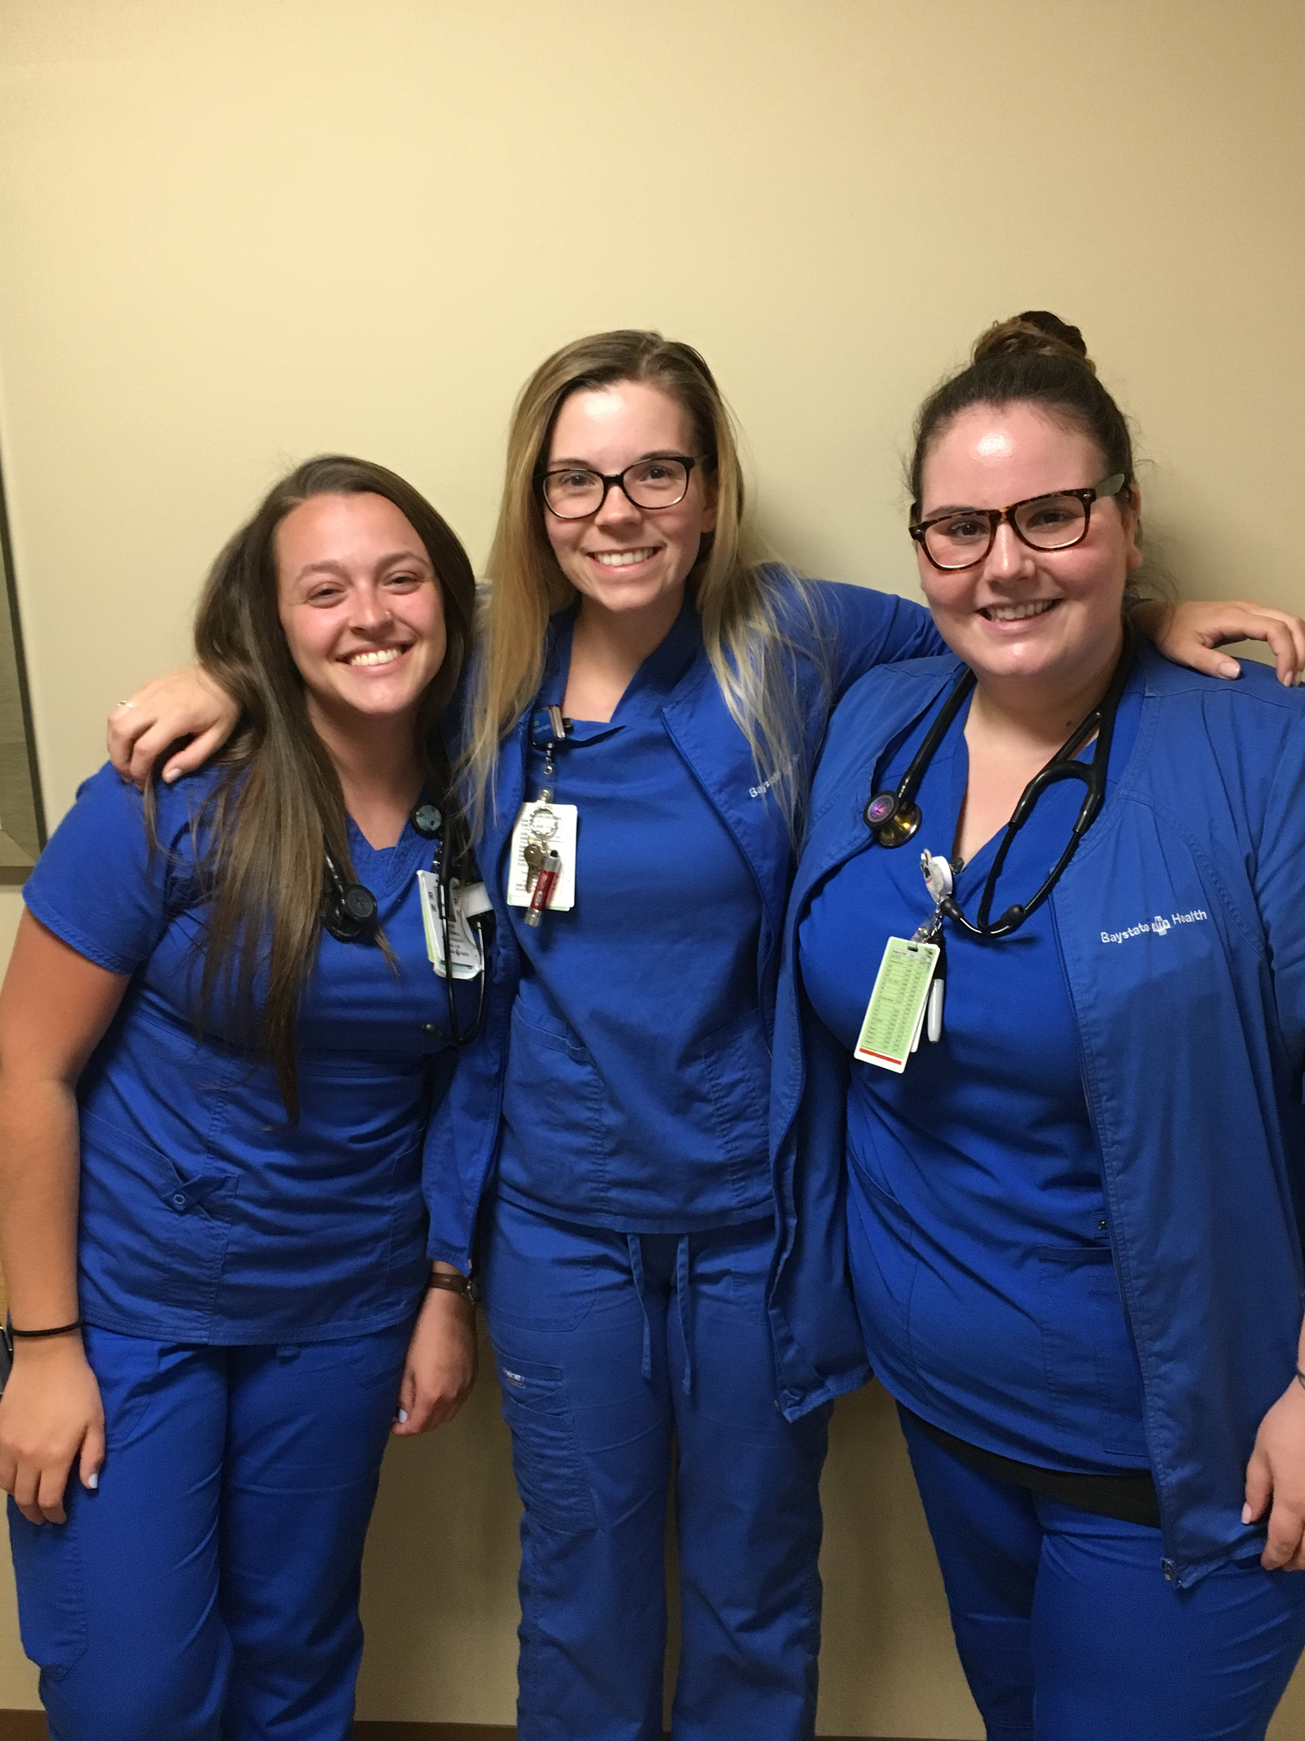

* For more information:

**Google us:**

Baystate Health

Nurse Residency Program

**Contact:**

Alyson Wrisley, PhD, RN

Director, BH Nurse Residency Program

Brittany Patterson, MSN, RN

Manager, BH Nurse Residency Program

Julie Racicot, MSN, RN, NPD-BC, CCRN

NurseResidencyProgram@baystatehealth.org



**Baystate Health**

**Nurse Residency Program**

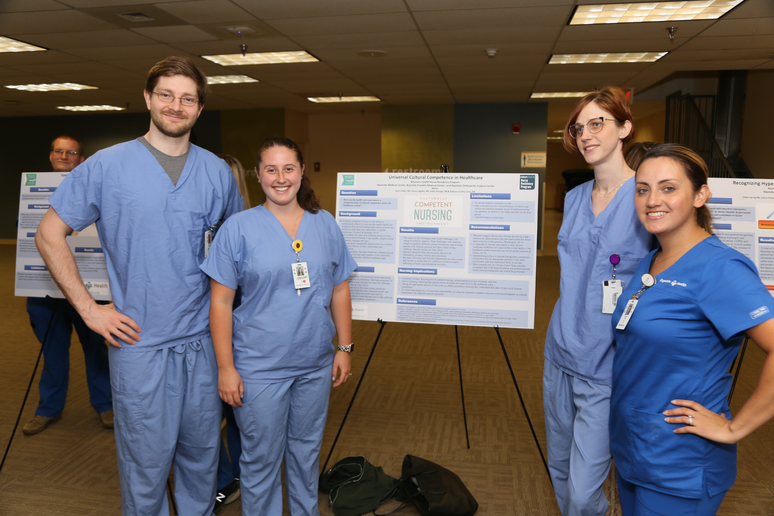

*The transition from nursing student or novice nurse to professional nurse can be challenging. Baystate Health offers a Nurse Residency Program, which is dedicated to supporting and developing new nurses in their careers.*

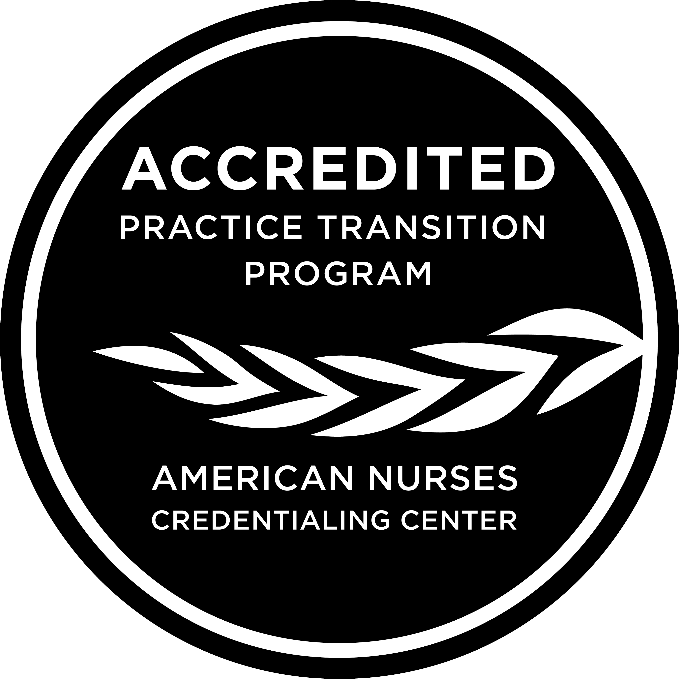

#### Benefits of the BH Nurse Residency Program

* Guidance from dedicated, trained preceptors in an environment committed to learning
* Progressive orientation to enhance critical thinking and skill development using the theoretical model *From Novice to Expert*, Benner (2001)
* Membership in a supportive residency program
* Structured monthly educational seminars to develop confidence and competence in nursing practice
* Professional Pathway options to develop professional career with choices
* Customized career planning support
* Exposure to organizational leadership strategies and professional development opportunities
* Support in incorporating evidence-based outcomes practices into clinical care

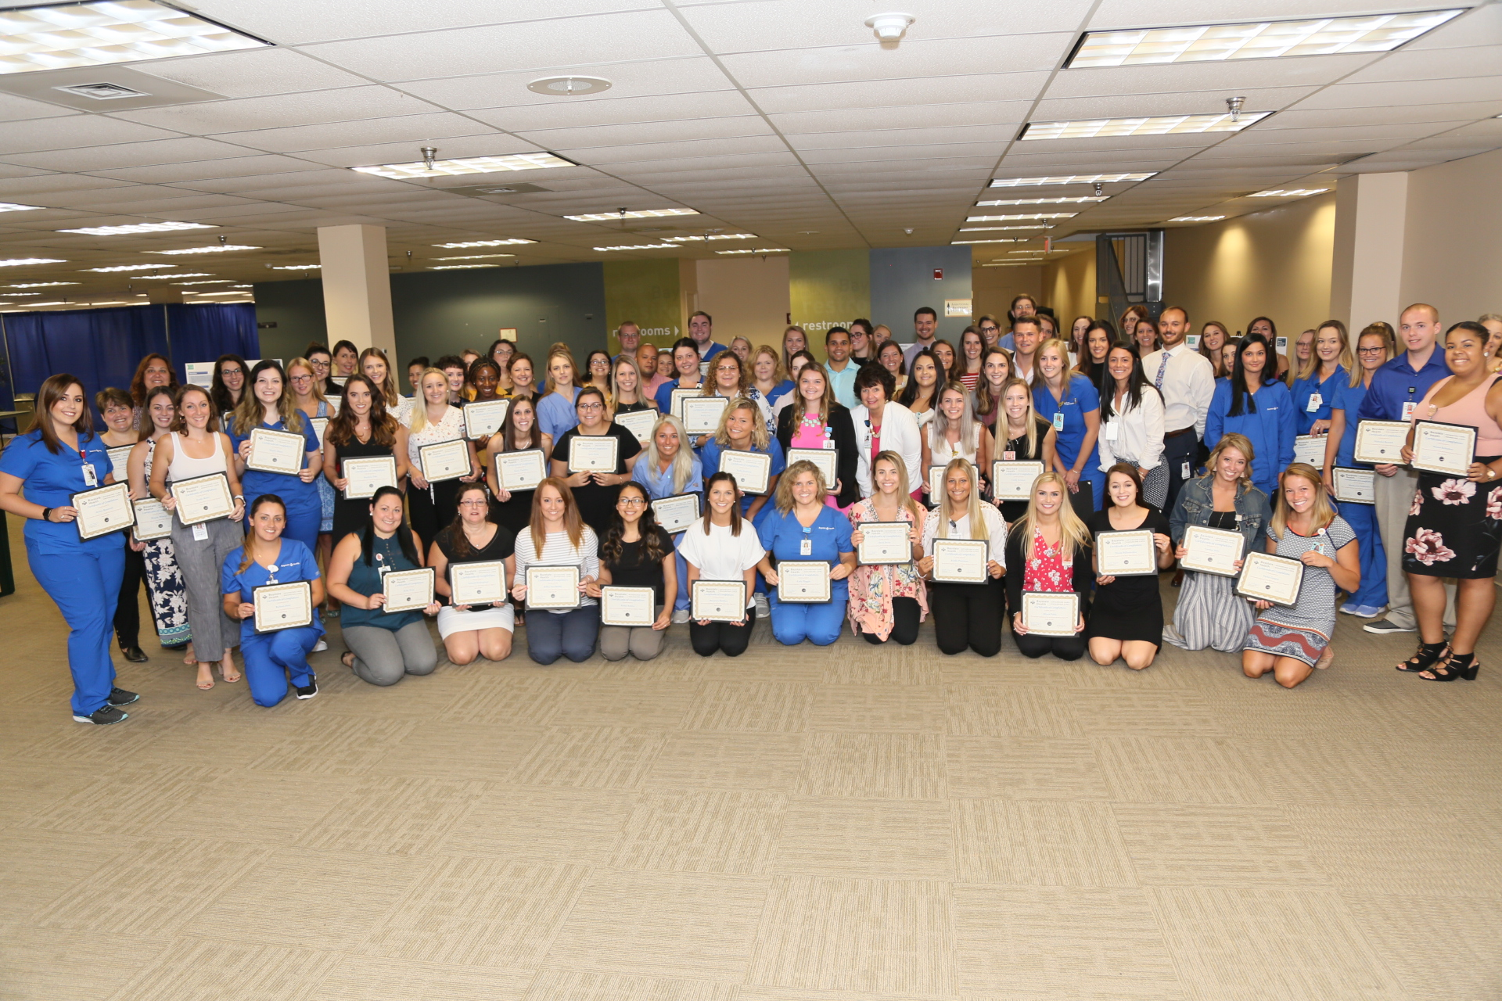

* **Nurse Residency Program at Baystate Health**
* The Nurse Residency Program (NRP) designed for nurses with less than 12 months experience, prepares you to be successful as a full partner on the health care team. The 10-month long program provides a structured curriculum to educate and empower you to function autonomously within your nursing specialty. Nurse residents attend and actively participate in nursing orientation, CIS orientation, unit-based orientation, NRP seminars, quality initiative education, and annual healthcare validations.
* The Baystate Health NRP provides a platform for continued professional development. We strengthen the relationship between academics and service and offer individualized learning plans, mentorship and peer support, leadership concepts, and heightened visibility for career development within the Baystate Health integrated health care system.

***When you complete the Nurse Residency Program, you will have the knowledge and skills to:***

* Demonstrate effective critical thinking and reasoning skills related to clinical judgment and practice
* Incorporate evidence-based practices to patient outcomes and the patient care experience

Rev. 10/2021

* Provide quality and safe clinical leadership at the point of care
* Prepare for clinical advancement
* Implement clinical decision-making skills through interprofessional collaboration opportunities

* **Nurse Resident Testimonial Statements**
* “I am beyond excited to start in a field that I love and continue my education as a nurse resident, as well as join the Baystate Health team!”

-Erin Z, BSN, RN

* “I did not think twice as I learned of Baystate Medical Center’s Magnet accreditation, glowing patient reviews and the strong curriculum for the new nurse graduates”

-Will C, BSN, RN

* **Application Criteria**
* Graduate from an accredited nursing program (BSN, ADN, MSN, or DNP)
* Less than 12 months experience working as a registered nurse
* Senior practicum conducted in an area of specialty is preferred
* Massachusetts RN licensure

***How to Apply:***

* Apply online through the Baystate Health

Career Opportunities website:

https://baystatehealthjobs.com/nursing/

* **Nurse Residency Program Locations**
* Baystate Medical Center/

Baystate Children’s Hospital

* Baystate Franklin Medical Center
* Baystate Wing Hospital
* Baystate Noble Hospital

